Bangladesh Medical Association (BMA)
List of Life Member-37
64. BMA Sunamganj Branch

Sl No | Voter No | Voter Details
1 | Voter No  LM-6400001  No Image | DR. MD. ABDUL MUNIM  F/Name: Late Mvi. Abdul Wahab  M/Name:  BM & DC Reg. No:  NID:  Cell:  Address: Civil Surgeon  Sunamgonj  Blood Group:
2 | Voter No  LM-6400002  No Image | DR. DIPAK LAL BANIK  F/Name:  M/Name:  BM & DC Reg. No:  NID:  Cell:  Address: Medical Officer, Shunamganj  Blood Group:  TRANSFERED to BMA Dhaka City  LM-1405543
3 | Voter No  LM-6400003 | DR. GOUTAM ROY  F/Name: Late Birendra Lal Roy  M/Name:  BM & DC Reg. No:  NID:  Cell:  Address: Buktar Para, Diganta- 22  Sunamgonj  Blood Group:
4 | Voter No  LM-6400004  No Image | DR. SANKAR NARAYAN DAS  F/Name:  M/Name:  BM & DC Reg. No:  NID:  Cell:  Address: Sunamgonj.  Blood Group:  TRANSFERED to BMA Dhaka City  LM-1405543
5 | Voter No  LM-6400005  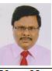 | DR. MD. ABDUL HAKIM  F/Name: Hajee Ali Akbar  M/Name:  BM & DC Reg. No:  NID:  Cell: 01715097087  Address: Sadar Hospital Quarter  Sunamgonj  Blood Group:
6 | Voter No  LM-6400006  No Image | DR. MD. AMJAD HOSSAIN KHAN  F/Name:  M/Name:  BM & DC Reg. No:  NID:  Cell:  Address:  Blood Group:
7 | Voter No  LM-6400007 | DR. BISWAJIT GOLDER  F/Name: Late. Kalipada Golder  M/Name: Ahladini Golder  BM & DC Reg. No: 19567  NID:  Cell: 01711860548  Address: Doctors Quarter (Jr. Consultant) Sadar Hospital, Sunamgonj.  Blood Group: AB+
8 | Voter No  LM-6400008  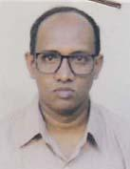 | DR. ASHUTUSH DAS  F/Name: Late. Ahlad Chandra Das  M/Name: Mrs. Neoti Rani Das  BM & DC Reg. No: 14854  NID: 10162436906  Cell: 01712516532  Address: Medical Officer, Sadar Hospital Sunamgonj Residence, Badhan, 11/A Womens College Road, Sunamgonj.  Blood Group: O+
9 | Voter No  LM-6400009 | DR. MD. GOLAM MUSTAFA  F/Name:  M/Name:  BM & DC Reg. No: 18761  NID: 6112029490679  Cell: 01711961795  Address: Medical Officer (MCH-FP) Sadar Sunamgonj & MCWC Sunamgonj.  Blood Group: O+  TRANSFERED to BMA Dhaka City  LM-1405543
10 | Voter No  LM-6400010 | DR. MD. JASIM UDDIN KHAN  F/Name: Madhu Khan  M/Name: Umme Kulsum  BM & DC Reg. No: 19187  NID: 9028904223028  Cell:  Address: Doctors quarter (MD Clinic) M.C.W.C Sunamgonj.  Blood Group: B+
11 | Voter No  LM-6400011  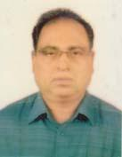 | DR. MUKUL RANJAN CHAKRABORTY  F/Name: Jatindra Chandra Chakraborty  M/Name: Noni Bala Chakraborty  BM & DC Reg. No: 16309  NID: 9028904224963  Cell: 01749577633  Address: Medical Officer, Sadar Hospital, Sunamgonj.  Blood Group: B+
12 | Voter No  LM-6400012 | DR. ATUL KUMAR MAZUMDAR  F/Name: Late. Komol Krishna Mazumdar  M/Name: Late. Chapala Mazumdar  BM & DC Reg. No: 20725  NID: 9028902215034  Cell: 01720145867  Address: 81, Upatayaka, Hason Nagar, Dist: Sunamgonj  Blood Group: B+
13 | Voter No  LM-6400013  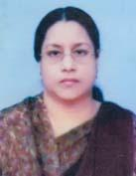 | DR. MALEKA BAHAR LAILY  F/Name: Md. Abdul Maleque  M/Name: Late. Gul Bahar Chowdhury  BM & DC Reg. No: 17849  NID: 9028902215184  Cell: 01715171858  Address: Surma 26, Shologhar, Sunamgonj.  Blood Group: A+
14 | Voter No  LM-6400014 | DR. NANI BHUSHAN TALUKDER  F/Name: Late. Guru Dayal Das Talukder  M/Name: Late. Surja Bala Talukder  BM & DC Reg. No: 19735  NID: 9028905228395  Cell: 01714697827  Address: 4a/A, Badhan R/A Womens College Road, Sunamgonj.  Blood Group: O+
15 | Voter No  LM-6400015 | DR. ATANU BHATTACHARJEE  F/Name: Ajoy Shankar Bhattacharjee  M/Name: Mina Rani Bhattacharjee  BM & DC Reg. No: 39828  NID: 9028905229197  Cell: 01711108482  Address: Niloy 149, Notun Para, Sunamgonj.  Blood Group: B+
16 | Voter No  LM-6400016 | DR. NILAXMI SHEKHAR TALUKDER  F/Name: Nikhil Ranjan Talukder  M/Name: Mamata Talukdet  BM & DC Reg. No: 63871  NID: 9196201102553  Cell: 01722616180  Address: Jamalganj, Upazila Health Complex, Jamalganj, Sunamganj  Blood Group: A+
17 | Voter No  LM-6400017  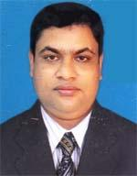 | DR. MOHAMMAD ANAMUL HAQUE KHAN  F/Name: Mohammad Abul Hasham Khan  M/Name: Amena Khatun  BM & DC Reg. No: 39049  NID: 19776117287388549  Cell: 01823289987  Address: Sadar Hospital , Sunamganj  Blood Group: B+
18 | Voter No  LM-6400018  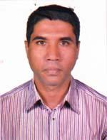 | DR. MOHAMMAD RAFIQUL ISLAM  F/Name: Mohammad Abdullah  M/Name: Tayabun Nessa  BM & DC Reg. No: 37224  NID: 19779196203123352  Cell: 01712238447  Address: Hospital Quatar Sunamganj  Blood Group: O+
19 | Voter No  LM-6400019 | DR. JOHORLAL DAS  F/Name: Jogoshwar Das  M/Name: Chaya Rani Das  BM & DC Reg. No: 41735  NID: 9028905230357  Cell: 01717144693  Address: Niloy-26/1(KA), Notunpara, Post & Dist-Sunamganj  Blood Group: O+
20 | Voter No  LM-6400020  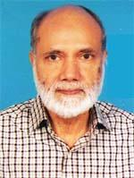 | DR. SYED MUNAWAR ALI  F/Name: Late Syed Suruj Ali  M/Name: Late Syeda Atlabun Nessa  BM & DC Reg. No: 4297  NID:  Cell: 01711382867  Address: Purobi R/A, Hasonnogor, Post+Dist-Sunamganj  Blood Group: AB+
21 | Voter No  LM-6400021 | DR. MONI RANI TALUKDER  F/Name: Monu Ranjan Talukder  M/Name: Late Mira Talukder  BM & DC Reg. No: 46156  NID: 9196221341553  Cell: 01754666042  Address: Meghna Hospital Querter, Derai, Sunamganj  Blood Group: B+
22 | Voter No  LM-6400022  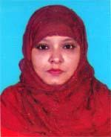 | DR. NAJIA MANALUL ISLAM  F/Name: A N M Serajul Islam  M/Name: Mrs. Rabeya Akhter  BM & DC Reg. No: 49932  NID: 19836125215289391  Cell: 01924757072  Address: Padma-3, Hospital Quarter , Derai UHC, Derai, Sunamganj  Blood Group: O+
23 | Voter No  LM-6400023  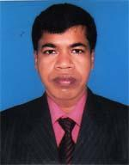 | DR. MD. HASHIBUR RAHAMAN  F/Name: Md. Aftab Uddin  M/Name: Mrs. Johura Khatun  BM & DC Reg. No: 35524  NID: 5714763454373  Cell: 01712161872  Address: Padma-3, Hospital Quarter, Derai UHC, Derai, Sunamganj  Blood Group: O+
24 | Voter No  LM-6400024  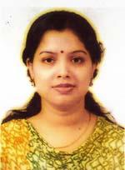 | DR. KANTA NARAYAN CHAKRABORTY  F/Name: Narayan Chakraborty  M/Name: Ratna Chakraborty  BM & DC Reg. No: 60064  NID: 1916765152888  Cell: 01724813831  Address: Niloy-149, Notunpara, Sunamganj  Blood Group: O+
25 | Voter No  LM-6400025  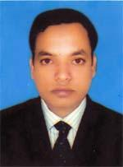 | DR. MOHAMMAD ABUL KALAM  F/Name: Md. Abdullah  M/Name: Rezia Khatun  BM & DC Reg. No: 49936  NID: 9018933346200  Cell: 01740885080  Address: R/S Bhavan, Ukilpara, Sunamganj  Blood Group: O-
26 | Voter No  LM-6400026  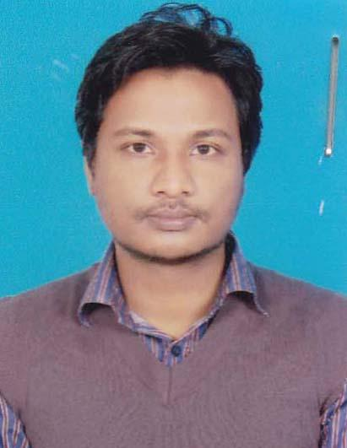 | DR. EHTESHAMUL HAKIM  F/Name: Dr. Md. Abdul Hakim  M/Name: Late. Nurun Nahar  BM & DC Reg. No: 77801  NID: 2853548101  Cell: 01706400633  Address: 31. Pallobi, Nahar Abash, Alipara, Sunamganj.  Blood Group: B+
27 | Voter No  LM-6400027  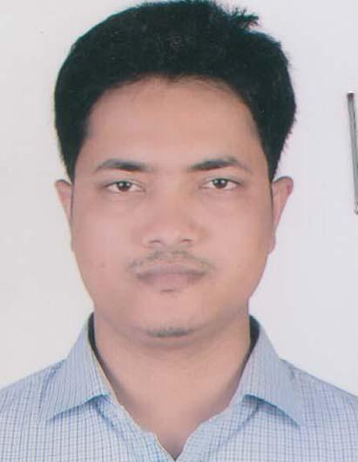 | DR. SABBIR AHMED  F/Name: Abul Kalam  M/Name: Mahmuda Begum  BM & DC Reg. No: 66370  NID: 19879028905226187  Cell: 01952960073  Address: Niloy-122/1, Natun para, Sunamgonj.  Blood Group: B+
28 | Voter No  LM-6400028  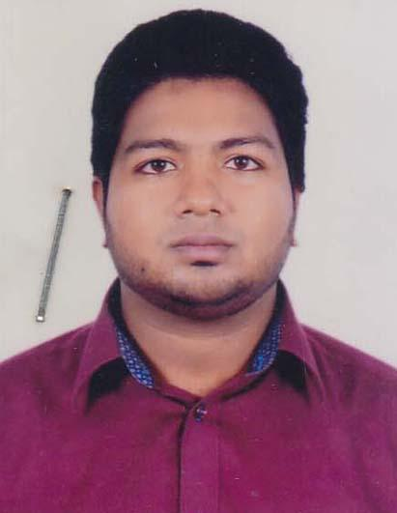 | DR. SALEH AHMED HAMIDI  F/Name: Sultan Ahmed Hamidi  M/Name: Dilroba Begum  BM & DC Reg. No: 72567  NID: 19906826012000170  Cell: 01626888000  Address: House No: Shahbag-1, 1st Floor Shuloghor Colony Road, Sunamgonj.  Blood Group: B+
29 | Voter No  LM-6400029  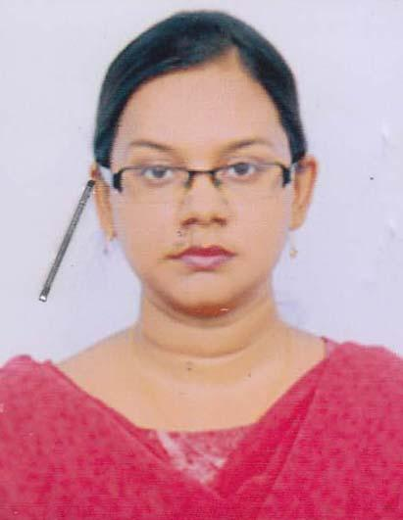 | DR. FARHA WAHID  F/Name: Dr. K.m. Wahidul Haque  M/Name: Razia Nawshaba  BM & DC Reg. No: 71993  NID: 19902695433000167  Cell: 01912688028  Address: House No: Shahbag-1, 1st Floor Shuloghar colony Road, Suamagonj.  Blood Group: B+
30 | Voter No  LM-6400030  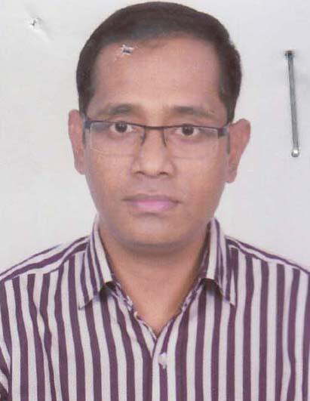 | DR. SUJIT CHANDRO SARKAR  F/Name: Sorab Chandro Sarkar  M/Name: Doli Rani Sarkar  BM & DC Reg. No: 49362  NID: 5999762502  Cell: 01629575787  Address: Jail Road, Old Hospital, Sunamganj  Blood Group: A+
31 | Voter No  LM-6400031  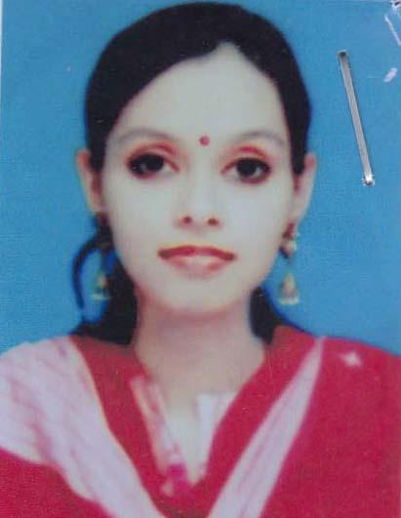 | DR. ISRAT JAHAN  F/Name: Abdul Mazid  M/Name: Saleha Begum  BM & DC Reg. No: 74832  NID: 19879028905226187  Cell: 01912270590  Address: Anabil-63, Ukipara, Sunamgonj.  Blood Group: B+
32 | Voter No  LM-6400032  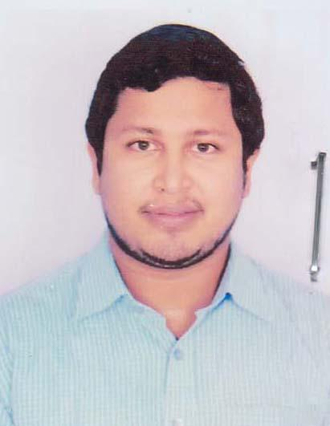 | DR. SAIKAT DAS  F/Name: Sukesh Chandra Das  M/Name: Shukla Chowdhury  BM & DC Reg. No: 81395  NID:  Cell: 01726701012  Address: Upytoka34, Hasonnagor, Sunamgonj.  Blood Group: n_a
33 | Voter No  LM-6400033  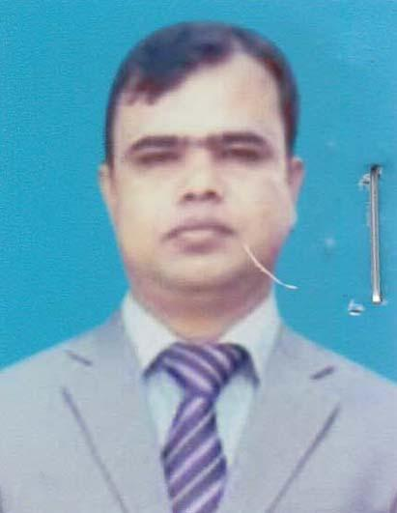 | DR. NURUL ISLAM  F/Name: Abdul Gani Mia  M/Name: Shalan Begum  BM & DC Reg. No: 52421  NID: 1992028904000023  Cell: 01719373522  Address: 162/5, Sumna R/A, Sunamgonj.  Blood Group: AB+
34 | Voter No  LM-6400034  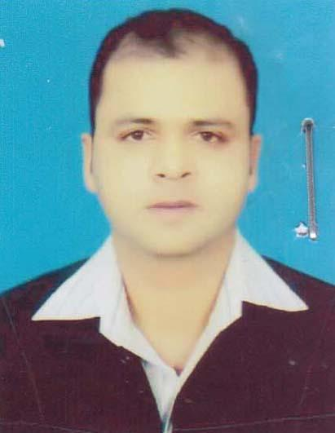 | DR. ZASIM UDDIN  F/Name: Shorif Ullah  M/Name: Joriful Bibi  BM & DC Reg. No: 45057  NID: 1981901279440107  Cell: 01712145516  Address: South Sunamganj, Sunamganj.  Blood Group: B+
35 | Voter No  LM-6400035  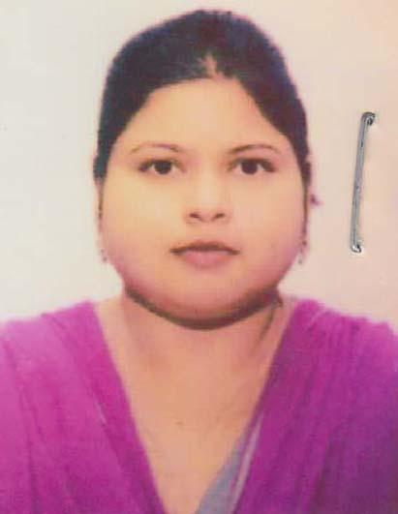 | DR. KONIJ RAHIMA RABBANI  F/Name: Late. Golam Rabbani  M/Name: Shamsunnahar Begum Shahana  BM & DC Reg. No: 85177  NID: 5090611574  Cell: 01717541424  Address:  Blood Group: O+
36 | Voter No  LM-6400036  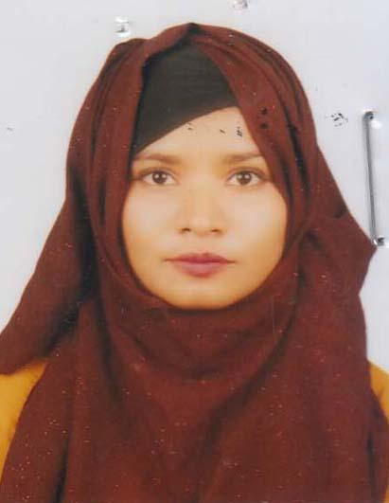 | DR. SAMIHA FARHAT  F/Name: Dr. Mohammad Abdul Quayyum  M/Name: Dr. Rokeya Khanam  BM & DC Reg. No: 79342  NID: 19922650898000616  Cell: 01772684429  Address: pallabi 31, Nahar Abas, Alipara, sunamgonj.  Blood Group: B+
37 | Voter No  LM-6400037  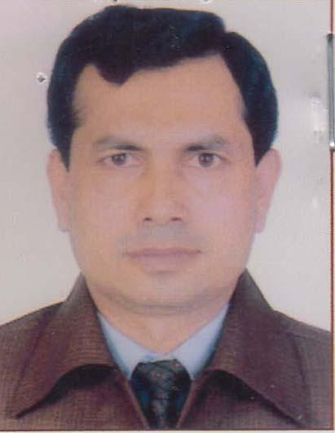 | DR. MOHAMMAD BADRUL ALAM  F/Name: Abdur Rob  M/Name: Hazera Khatun  BM & DC Reg. No: 36381  NID: 3263254520  Cell: 01711070903  Address: Vill: Anwarpur, Ward-09, Derai Pourashava, Sunamgonj.  Blood Group: O+

